 | Village Green | Defibrillator | Leander Post 1 | Leander 2
Date of Acquisition, upgrade and disposal | Acquired 2005  Revalued 2010  Leased to KGT 2011. | Acquired 2024 | 18/02/2022  Installed by SCC  Adopted by KPC | 18/02/2022  Installed by SCC  Adopted by KPC
Cost of acquisition and upgrades. | £13,600 | £1,665 | Donated | Donated
Useful lifetime estimate | Indefinite | 10 years | Indefinite | Indefinite
Location | Behind houses of the Street and Church Road. | Mounted to wall outside the Village Hall IP13 7JZ | T Junction  The Street  Kettleburgh | Junction Rectory Rd and The Street  Kettleburgh
Responsibility | KGT | Cllr R. Booth + volunteers  Scheme Controller Clerk | Parish Council | Parish Council
Present use and capacity (Including periodic use measures) | Daily use by community . | Currently fully  maintained as 24 hour availability. | Permanent position | Permanent position
Value | £1 | £1,750 | £1,270 | £1,270
Value Type | Nominal | Replacement | Replacement | Replacement
Condition | Good | Defibrillator Device – Excellent  Cabinet – Excellent. | New | New
Usage Charges | None | None | None | None

 | Noticeboard | The Pound | Village Sign | Marquee Pro Elite 12 m x 6m
Date of Acquisition, upgrade and disposal | Donated by KGT May 2006 | Registered by The Commons Registration Act 1965 on 2nd November 1979 |  | Purchased May 2022 including heavy duty Tent Peg and set of 2 Ratchet down storm straps and pegs.
Cost of acquisition and upgrades. | Donated |  | Donated | Purchase price: £1904.35 Net, £380.87 VAT, Total Gross Price £2285.22 Stored securely at a local property.
Useful lifetime estimate | 20 | Indefinite | Indefinite
Location | Lings Field | Mill Lane | The Street (just off) opposite Street Farm Barns. | Stored securely at a local property.
Responsibility | Clerk | Kettleburgh PC  Cllr E.Jardine Chairman  Mill Lane | Clerk | Clerk
Present use and capacity (Including periodic use measures) | Constant use |  | Village Sign | Periodic use –likely annual village events
Value | £1,600 | £1,000 | £4,000 | Purchase price: £1904.35 Net, £380.87 VAT, Total Gross Price £2285.22
Value Type | Replacement |  | Replacement | Replacement
Condition | Fair | Well maintained | Good | New with guarantee
Usage Charges | None | None | None | None

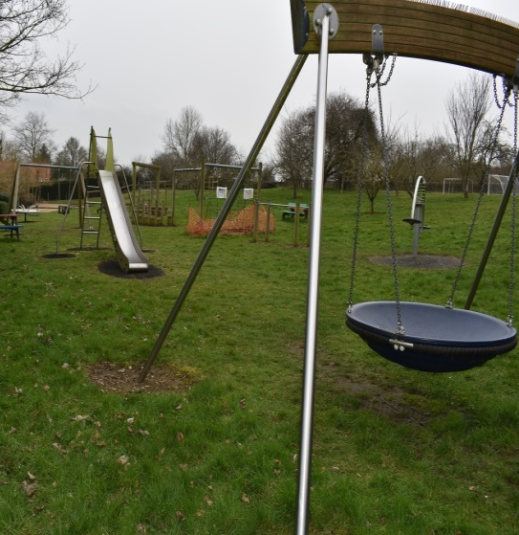  Figure 1 Kettleburgh Village Green TM 266 604 | 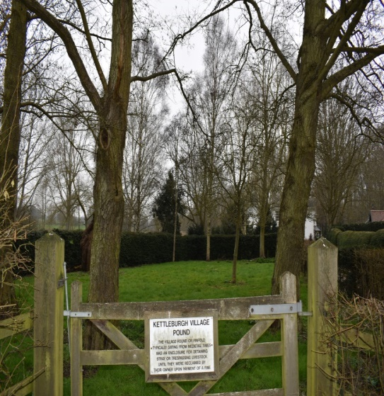  Figure 2 Kettleburgh Pound TM 264 597 |   Figure 3 Village Sign TM 265 602 | 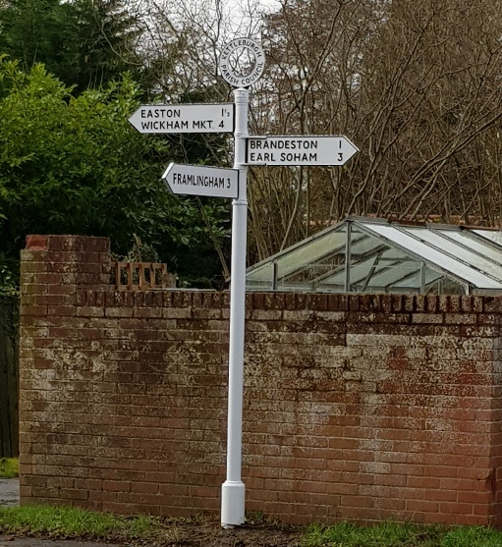  Figure 4 Leander Heritage Sign TM 263 601  T-Junction The Street & Easton Rd
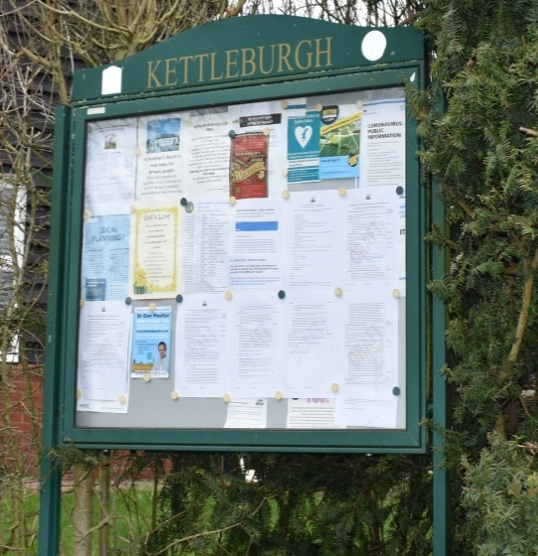  Figure 5Kettleburgh Noticeboard TM 44 602 | 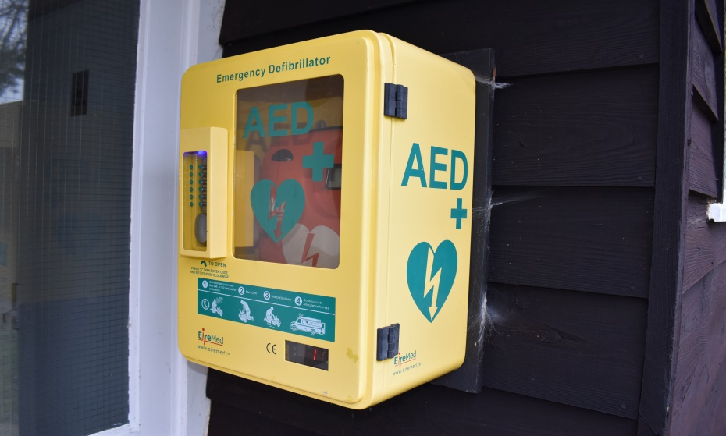  Figure 6 Kettleburgh Defibrillator TM 267 603 | 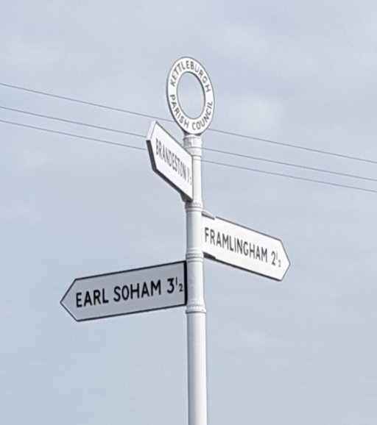  Figure 7 Leander Heritage Sign TM 268 605  Rectory Rd and The Street Junction | 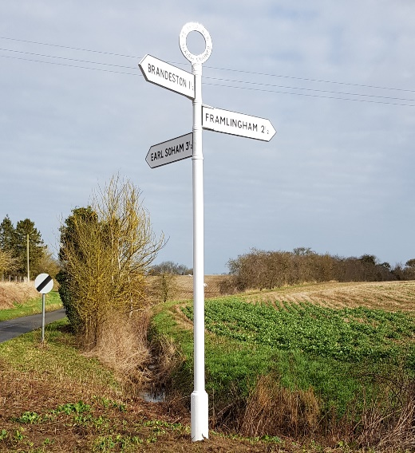  Figure 7 Leander Heritage Sign TM 268 605  Rectory Rd and The Street Junction

Approved at KPC Annual Meeting – 19 May 2026 Minute Ref: 26/37
Total asset value: £13,176.22 at 19 May 2026

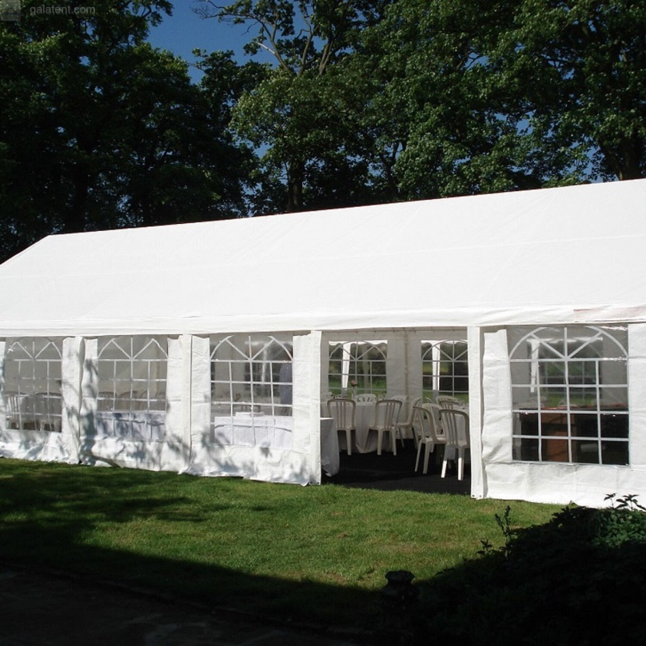 | 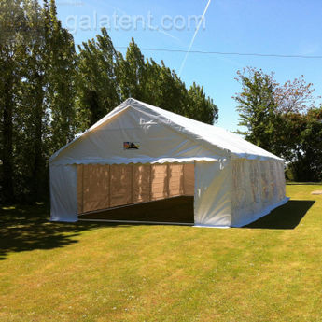 | 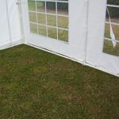
Stock Photo from Gala Tents website https:www.galatent.co.uk. Gala Tent Code: 11329 – 6m x 12m Gala Tent Marquee Pro Elite (100 %PVC)
Purchased May 2022 including heavy duty Tent Peg and set of 2 Ratchet down storm straps and pegs.
Purchase price: £1904.35 Net, £380.87 VAT, Total Gross Price £2285.22 Stored securely at a local property.

